Scalable Blog Hosting Platform Using AWS VPC,EC2, and RDS

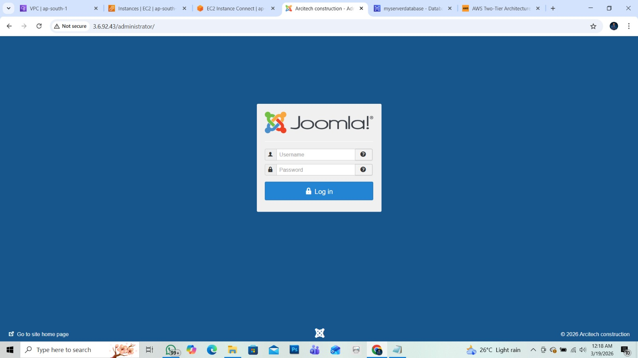

_ASHOK.S

CONTENTS

- Introduction
- Vpc
- Set Up Networking
- Set Up the Web Tier
- Set Up the Database Tier
- Install and Configure Joomla
- Output

INTRODUCTION

Architecture is a client-server model where the application is divided into two main layers: the Client Tier and the Database Tier. In this setup, client computers directly communicate with the database server to request and manage data. The client tier handles the user interface and application logic, while the database tier stores and manages the data. This architecture is simple, cost-effective, and suitable for small to medium-sized applications. It provides faster communication since there is no intermediate layer between the client and the database. However, it may face scalability and security challenges as the number of users increases.

Set Up Networking:
VPC Settings:
VPC only
Name: my_server_vpc
IPv4 CIDR block: IPv4 CIDR manual input
IPv4 CIDR: 10.0.0.0/16
IPv6 CIDR block: No IPv6 CIDR block
Click “Create VPC”

Next create the Internet Gateway
Select “Internet Gateway” from the VPC dashboard
Name: MY_BLOG_HOSTIGW
Click “Create Internet Gateway”
Attach the Internet Gateway to my VPC

Subnet Creation:
Now I will create 2 public subnets and 2 private subnets
Select “Subnets” from the VPC dashboard
Click create subnet
Select my VPC for the subnets
Subnet Name: Publicsubnet-1
AZ: MUMBAI Ap-south-1a
IPv4 subnet CIDR block: 10.0.1.0/24

Add Subnet
Subnet Name: Publicsubnet-2
AZ: MUMBAI Ap-south-1b
IPv4 subnet CIDR block: 10.0.2.0/24
Add subnet
Subnet Name: Privatesubnet-1
AZ: MUMBAI Ap-south-1a
IPv4 subnet CIDR block: 10.0.3.0/24

Add subnet
Subnet Name: Privatesubnet-2
AZ: MUMBAI Ap-south-1b
IPv4 subnet CIDR block: 10.0.4.0/24

Click “Create Subnet”
Select Route tables in the VPC dashboard
Create 2 Route Table for both public and private subnet
1)
Name:My Public RT
VPC: my_server_vpc
Click “Create route table”

2)
Name:My Private RT
VPC: my_server_vpc
Click “Create route table”

The Public Route Table needs to be associated with my public subnets for this go to Subnets associations tab after selecting the Route Table and then click Edit subnet associations
Select the 2 public subnets and click save associations
Next the Private Route Table needs to be associated with my private subnets for this go to Subnets associations tab after selecting the Route Table and then click Edit subnet associations
Select the 2 private subnets and click save associations

Now we ensure that our created Route Tables are routed to Internet Gateway.
For this select the public route table and click edit routes
Then I selected my Internet Gateway and saved traffic to be routed.
Move to Your VPC to select the created VPC and check the resource map for the right connection.

Set Up the Web Tier:
Go to “EC2” in the console and click launch an instance
Name: my_web_server
AMI: Ubuntu
Instance type: t2micro
Key pair: ashokaura.pem
Edit the network settings
VPC: my_server_vpc
Subnet: PublicSubnet-1
Auto-assign public IP: Enable
Select the existing security group Default
Click “Launch instance”
Ensure that SSH, HTTP, and HTTPS are allowed in the default security group.

Set Up the Database Tier:
Go to RDS in the console and select subnet group in dashboard
Name: AWS Subnet Group
Description: Subnet Group
VPC: my_server_vpc
AZ: ap-south-1a
Subnet: Privatesubnet-1, Privatesubnet-2
Click “Create subnet group”
Select Database in dashboard and click create Database
Choose a database creation method: Full configuration
Engine options: MySQL
Templates: Sandbox Template
DB instance identifier: database-1
Master username: admin
Credentials management: Self-managed
Master password: admin12345
Confirm master password: admin12345
Compute resource: Connect to an EC2 compute resource
EC2 instance: my_web_server

DB subnet Group: AWS Subnet Group (we created)
Public Access: No
VPC security Group: Choose existing- default
Click “Create database”

Install and Configure Joomla
Connect to the EC2 instance to install the Joomla software by following these commands.
- sudo apt update
2)sudo apt install -y apache2 php libapache2-mod-php php-mysql php-xml php-gd unzip
3) sudo systemctl start apache2
4) sudo systemctl enable apache2
5) cd /var/www/html
6) sudo curl -L -o joomla.zip https://github.com/joomla/joomla-cms/releases/download/3.9.28/Joomla_3.9.28-Stable-Full_Package.zip
7) sudo unzip joomla.zip
8) sudo chown -R www-data:www-data /var/www/html
9) sudo chmod -R 755 /var/www/html
10) sudo rm /var/www/html/index.html
11) sudo nano /etc/apache2/mods-enabled/dir.conf
(Directory index- index.php index.html index.cgi index.pl index.xhtml index.htm)
12) sudo systemctl restart apache2

After install copy the publicip paste in new terminal Joomla page is open

CONFIGURATION
Site Name: Arcitech construction
Email: Awsashok28@gmail.com
Username: admin
Password: admin12345
Confirm Password: admin12345
Click Next
DATABASE
Database Type: MySQL
Host Name: myserverdatabase.c5e0oac0g70t.ap-south-1.rds.amazonaws.com
Username: admin
Password: admin12345
Database Name: database-1
Table Prefix: Default
Old Database Process: remove

if got an error message, so need to delete the file name created in the installation folder
- cd /var/www/html/installation

- sudo rm

Then put the database and click next and select blog English and Install
We need to remove the installation folder for that put this command
- sudo rm -rf /var/www/html/installation

EC2 connect
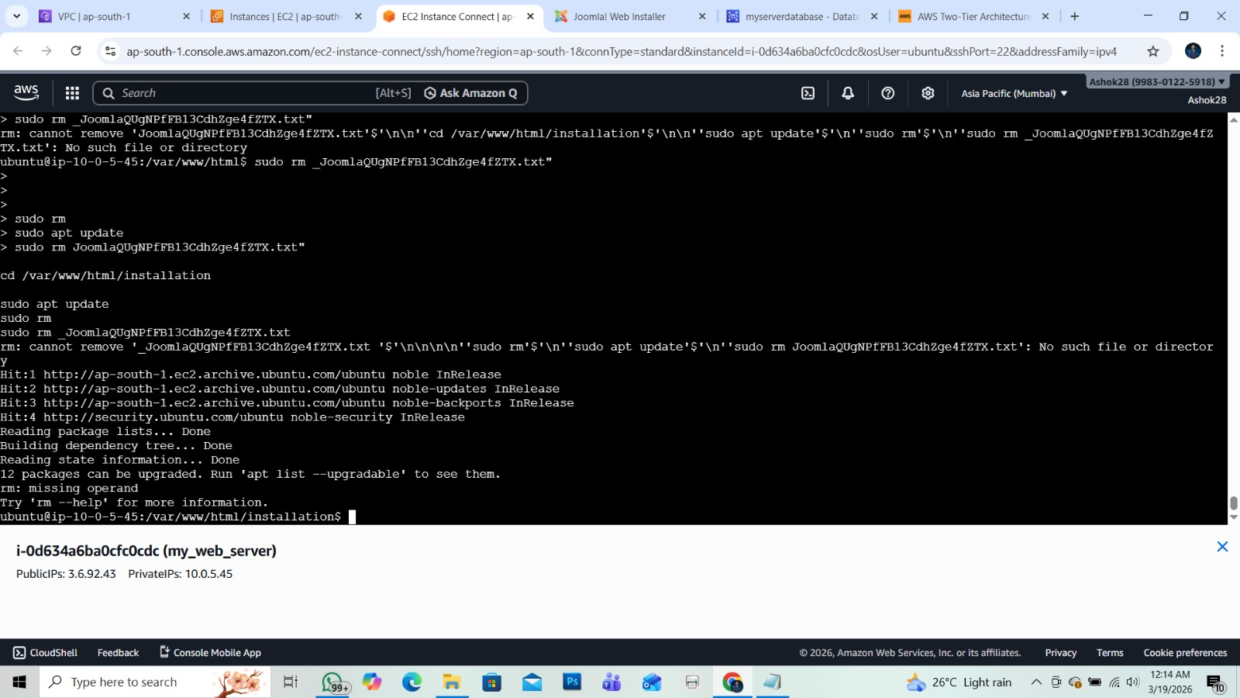

Frontpage
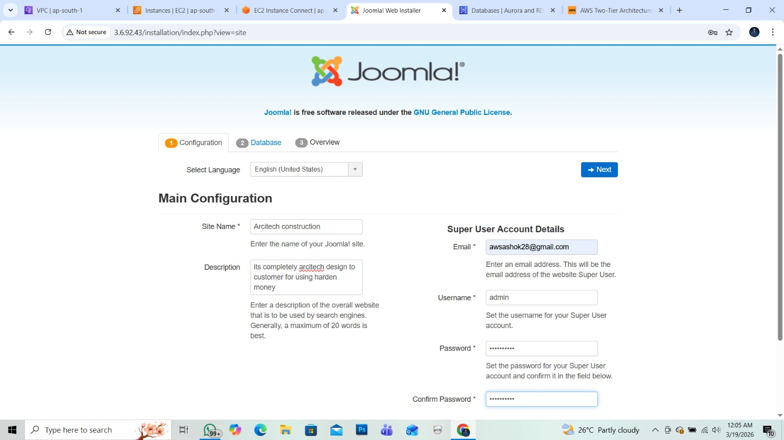

Database configure
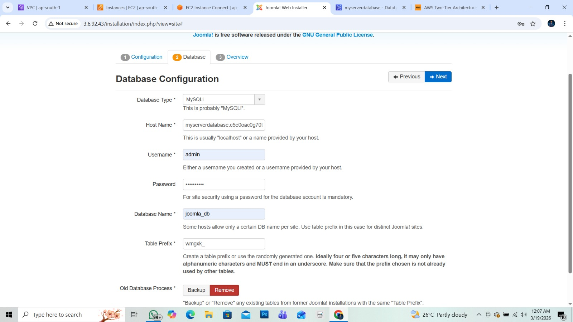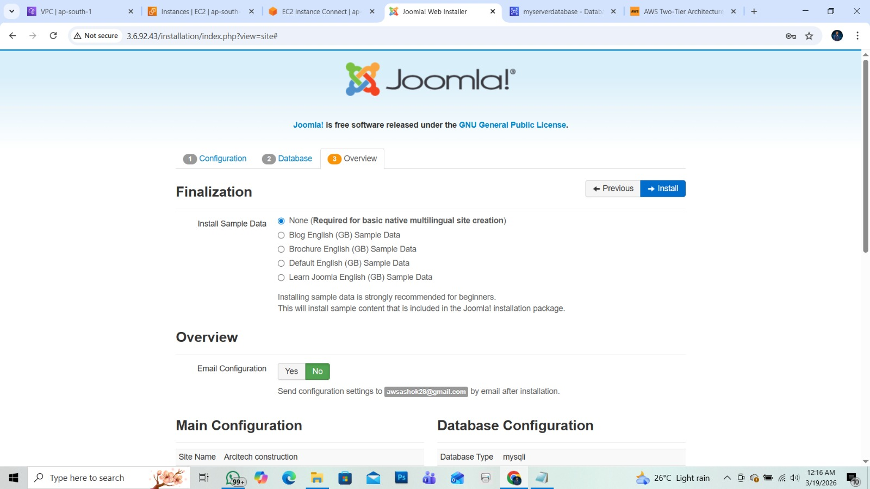\

Website login page



Thankyou

